**Multiprotocol Label Switching**

**By: Austin Tran-Struthers**



**Purpose**

To connect 2 separate OSPF networks together using 3 switches with MPLS running on them.

**Background**

Multiprotocol Label Switching (MPLS) is a technology widely used in computer networking to enhance the efficiency and performance of data packet forwarding. It was developed in the late 1990s as an improvement over traditional IP routing, aiming to address the limitations of routing protocols and increase packet forwarding speeds in large-scale networks.

At its core, MPLS works by labeling or tagging network packets allowing routers to make forwarding decisions based on the labels instead of reading the packets at each hop. The label based approach allows faster forwarding as routers can quickly match the labels to the predetermined paths, known as Label Switched Paths (LSPs), instead of performing complex header lookups.

The MPLS architecture consists of several key components. First there are Label Edge Routers (LERs) that interface with customer devices and assign labels to incoming packets. LERs are responsible for labeling packets based on a predetermined plan, such as destination IP address. Upon receiving labeled packets, LERs forward the packets to the Label Switching Routers (LSRs) within the network.

LSRs form the backbone of MPLS and are responsible for forwarding the labeled packets. They maintain a Label Forwarding Information Base (LFIB), which maps incoming labels to outgoing interfaces and labels. This forwarding table is dynamically updated using protocols such as the Label Distribution Protocol (LDP) ensuring efficient and optimal routing.

**Lab summary**

We used 3 Catalyst 3750 Metro layer 3 switches using MPLS to connect two networks running OSPF.

**Lab Commands**

**mpls ip** enables MPLS on the interface

**mpls label protocol ldp** makes the device able to to request, distribute and release label prefixes

**Network Topology**

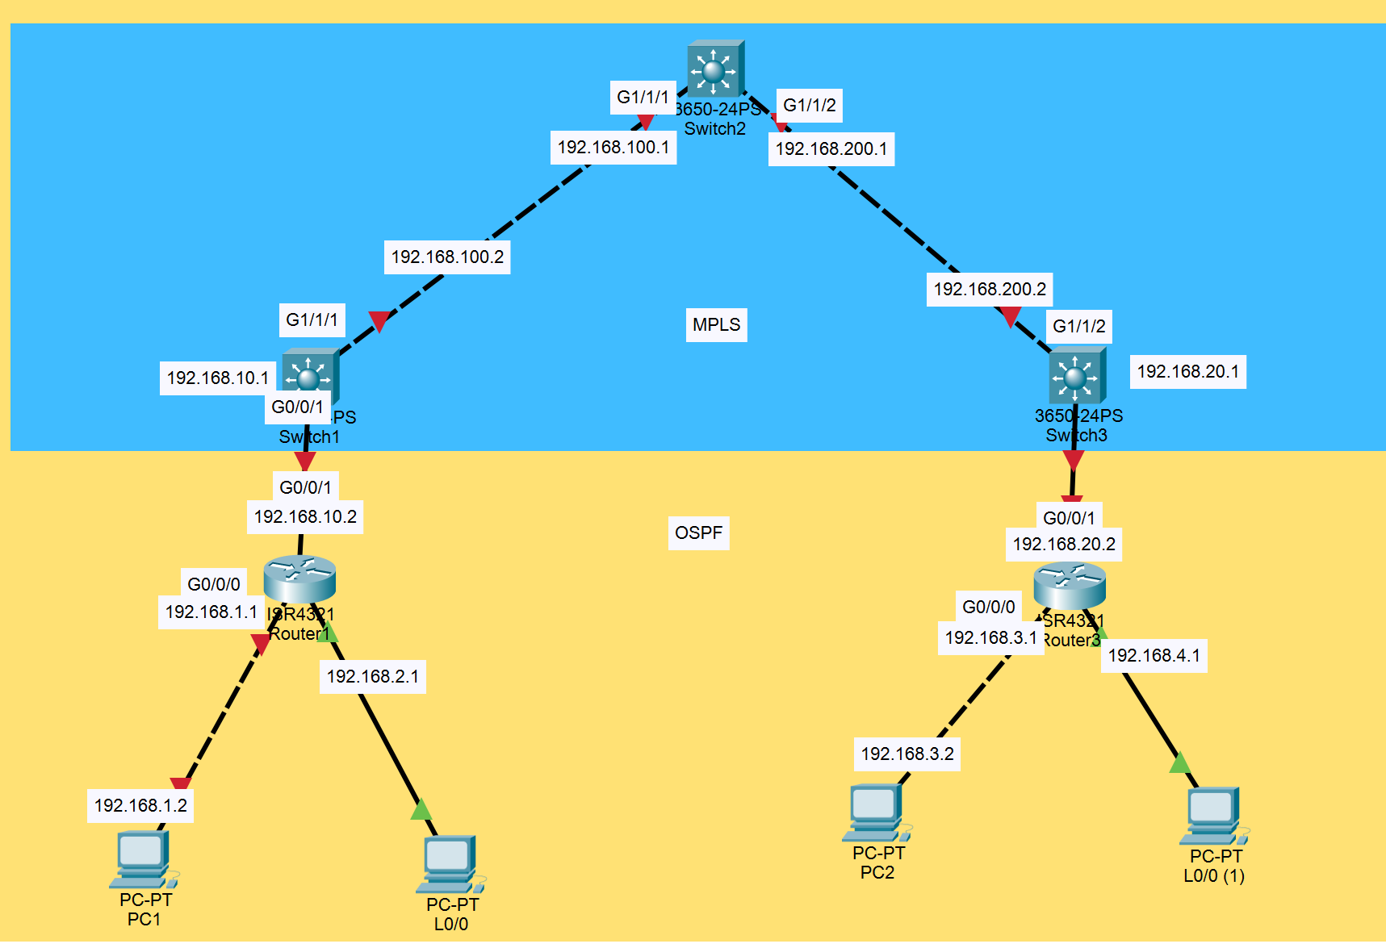

**Configurations:**

***Router and Switch Configurations***

***S1:***

version 12.2

no service pad

service timestamps debug datetime msec

service timestamps log datetime msec

no service password-encryption

hostname S1

boot-start-marker

boot-end-marker

no aaa new-model

system mtu routing 1500

ip routing

vtp domain cisco

vtp mode transparent

mpls label protocol ldp

crypto pki trustpoint TP-self-signed-2306271616

enrollment selfsigned

subject-name cn=IOS-Self-Signed-Certificate-2306271616

revocation-check none

rsakeypair TP-self-signed-2306271616

crypto pki certificate chain TP-self-signed-2306271616

certificate self-signed 01

3082023C 308201A5 A0030201 02020101 300D0609 2A864886 F70D0101 04050030

31312F30 2D060355 04031326 494F532D 53656C66 2D536967 6E65642D 43657274

69666963 6174652D 32333036 32373136 3136301E 170D3933 30333031 30303031

30315A17 0D323030 31303130 30303030 305A3031 312F302D 06035504 03132649

4F532D53 656C662D 5369676E 65642D43 65727469 66696361 74652D32 33303632

37313631 3630819F 300D0609 2A864886 F70D0101 01050003 818D0030 81890281

8100CD0A C3A64AA3 859BEAD9 486FCCFE 2007F50C 6A13D033 C100C212 07AC22E2

4CC0D9BC 01E1C4D0 FC7E6C29 06288F5D 567661F4 5D5D654B 3B00D4CA 899E61FC

AB1AB760 DE5B8199 B47ADA98 F59A26F5 440C6E3B 04F84CD5 621D92F2 7281060B

0FF6198B 637CDCE7 ACA97B4A 5C40C6B7 F4458641 A32B9604 803B8E31 9B817FBC

F9030203 010001A3 64306230 0F060355 1D130101 FF040530 030101FF 300F0603

551D1104 08300682 044C3353 31301F06 03551D23 04183016 8014872D 80596B32

07D59F05 43F2C4A0 4D9295F2 346F301D 0603551D 0E041604 14872D80 596B3207

D59F0543 F2C4A04D 9295F234 6F300D06 092A8648 86F70D01 01040500 03818100

8FF26091 40753AD5 4AB957A5 27AD833C 86B52DF6 FFD75C57 4F2E500A B46F2BAF

832DD245 F5D6F0C7 8EA4D4DC 66D4AEF5 C011330A 594AF4F2 3494D8B9 63C08C3B

FB5F3D15 5BEC4B09 9D4285F6 B2463601 A2EC2CC5 3419FC01 D03C2964 F5C9C68B

68995683 F5361594 EB776EFA EC68F20D 0962BEFB 5DCFC926 FCA753D0 BBCA0587

quit

spanning-tree mode pvst

spanning-tree extend system-id

vlan internal allocation policy ascending

interface FastEthernet1/0/1

no switchport

ip address 192.168.10.1 255.255.255.0

interface FastEthernet1/0/2

interface FastEthernet1/0/3

interface FastEthernet1/0/4

interface FastEthernet1/0/5

interface FastEthernet1/0/6

interface FastEthernet1/0/7

interface FastEthernet1/0/8

interface FastEthernet1/0/9

interface FastEthernet1/0/10

interface FastEthernet1/0/11

interface FastEthernet1/0/12

interface FastEthernet1/0/13

interface FastEthernet1/0/14

interface FastEthernet1/0/15

interface FastEthernet1/0/16

interface FastEthernet1/0/17

interface FastEthernet1/0/18

interface FastEthernet1/0/19

interface FastEthernet1/0/20

interface FastEthernet1/0/21

interface FastEthernet1/0/22

interface FastEthernet1/0/23

interface FastEthernet1/0/24

interface GigabitEthernet1/0/1

interface GigabitEthernet1/0/2

interface GigabitEthernet1/1/1

no switchport

ip address 192.168.100.2 255.255.255.0

speed auto 1000

mpls ip

interface GigabitEthernet1/1/2

interface Vlan1

no ip address

router ospf 1

network 192.168.10.0 0.0.0.255 area 0

network 192.168.100.0 0.0.0.255 area 0

ip http server

ip http secure-server

logging esm config

line con 0

line vty 0 4

login

line vty 5 15

login

end

***S2:***

version 12.2

no service pad

service timestamps debug datetime msec

service timestamps log datetime msec

no service password-encryption

hostname S2

boot-start-marker

boot-end-marker

no aaa new-model

system mtu routing 1500

ip routing

mpls label protocol ldp

spanning-tree mode pvst

spanning-tree extend system-id

vlan internal allocation policy ascending

interface FastEthernet1/0/1

interface FastEthernet1/0/2

interface FastEthernet1/0/3

interface FastEthernet1/0/4

interface FastEthernet1/0/5

interface FastEthernet1/0/6

interface FastEthernet1/0/7

interface FastEthernet1/0/8

interface FastEthernet1/0/9

interface FastEthernet1/0/10

interface FastEthernet1/0/11

interface FastEthernet1/0/12

interface FastEthernet1/0/13

interface FastEthernet1/0/14

interface FastEthernet1/0/15

interface FastEthernet1/0/16

interface FastEthernet1/0/17

interface FastEthernet1/0/18

interface FastEthernet1/0/19

interface FastEthernet1/0/20

interface FastEthernet1/0/21

interface FastEthernet1/0/22

interface FastEthernet1/0/23

interface FastEthernet1/0/24

interface GigabitEthernet1/0/1

interface GigabitEthernet1/0/2

interface GigabitEthernet1/1/1

no switchport

ip address 192.168.100.1 255.255.255.0

speed auto 1000

mpls ip

interface GigabitEthernet1/1/2

no switchport

ip address 192.168.200.1 255.255.255.0

speed auto 1000

mpls ip

interface Vlan1

no ip address

router ospf 1

network 192.168.100.0 0.0.0.255 area 0

network 192.168.200.0 0.0.0.255 area 0

ip http server

ip http secure-server

logging esm config

line con 0

line vty 5 15

end

***S3:***

version 12.2

no service pad

service timestamps debug datetime msec

service timestamps log datetime msec

no service password-encryption

hostname S3

boot-start-marker

boot-end-marker

no aaa new-model

system mtu routing 1500

ip routing

vtp domain CCNP

vtp mode transparent

mpls label protocol ldp

spanning-tree mode pvst

spanning-tree extend system-id

vlan internal allocation policy ascending

interface FastEthernet1/0/1

no switchport

ip address 192.168.20.1 255.255.255.0

interface FastEthernet1/0/2

interface FastEthernet1/0/3

interface FastEthernet1/0/4

interface FastEthernet1/0/5

interface FastEthernet1/0/6

interface FastEthernet1/0/7

interface FastEthernet1/0/8

interface FastEthernet1/0/9

interface FastEthernet1/0/10

interface FastEthernet1/0/11

interface FastEthernet1/0/12

interface FastEthernet1/0/13

interface FastEthernet1/0/14

interface FastEthernet1/0/15

interface FastEthernet1/0/16

interface FastEthernet1/0/17

interface FastEthernet1/0/18

interface FastEthernet1/0/19

interface FastEthernet1/0/20

interface FastEthernet1/0/21

interface FastEthernet1/0/22

interface FastEthernet1/0/23

interface FastEthernet1/0/24

interface GigabitEthernet1/0/1

interface GigabitEthernet1/0/2

interface GigabitEthernet1/1/1

interface GigabitEthernet1/1/2

no switchport

ip address 192.168.200.2 255.255.255.0

speed auto 1000

mpls ip

interface Vlan1

no ip address

shutdown

router ospf 1

network 192.168.20.0 0.0.0.255 area 0

network 192.168.200.0 0.0.0.255 area 0

ip http server

ip http secure-server

logging esm config

line con 0

line vty 5 15

end

***R1:***

version 16.9

service timestamps debug datetime msec

service timestamps log datetime msec

platform qfp utilization monitor load 80

no platform punt-keepalive disable-kernel-core

hostname R1

boot-start-marker

boot-end-marker

vrf definition Mgmt-intf

address-family ipv4

exit-address-family

address-family ipv6

exit-address-family

no aaa new-model

login on-success log

subscriber templating

vtp domain cisco

vtp mode transparent

multilink bundle-name authenticated

license udi pid ISR4321/K9 sn FDO21482HZX

no license smart enable

diagnostic bootup level minimal

spanning-tree extend system-id

redundancy

mode none

interface Loopback0

ip address 192.168.2.1 255.255.255.0

interface GigabitEthernet0/0/0

ip address 192.168.1.1 255.255.255.0

negotiation auto

interface GigabitEthernet0/0/1

ip address 192.168.10.2 255.255.255.0

negotiation auto

interface Serial0/1/0

no ip address

shutdown

interface Serial0/1/1

no ip address

shutdown

interface GigabitEthernet0

vrf forwarding Mgmt-intf

no ip address

shutdown

negotiation auto

router ospf 1

network 192.168.1.0 0.0.0.255 area 0

network 192.168.2.0 0.0.0.255 area 0

network 192.168.10.0 0.0.0.255 area 0

ip forward-protocol nd

no ip http server

no ip http secure-server

ip tftp source-interface GigabitEthernet0

control-plane

line con 0

transport input none

stopbits 1

line aux 0

stopbits 1

line vty 0 4

login

end

***R2:***

version 16.9

service timestamps debug datetime msec

service timestamps log datetime msec

platform qfp utilization monitor load 80

platform punt-keepalive disable-kernel-core

hostname R2

boot-start-marker

boot-end-marker

vrf definition Mgmt-intf

address-family ipv4

exit-address-family

address-family ipv6

exit-address-family

no aaa new-model

login on-success log

subscriber templating

vtp domain cisco

vtp mode transparent

multilink bundle-name authenticated

crypto pki trustpoint TP-self-signed-2105456491

enrollment selfsigned

subject-name cn=IOS-Self-Signed-Certificate-2105456491

revocation-check none

rsakeypair TP-self-signed-2105456491

crypto pki certificate chain TP-self-signed-2105456491

certificate self-signed 01

30820330 30820218 A0030201 02020101 300D0609 2A864886 F70D0101 05050030

31312F30 2D060355 04031326 494F532D 53656C66 2D536967 6E65642D 43657274

69666963 6174652D 32313035 34353634 3931301E 170D3233 30353136 32313336

30325A17 0D333030 31303130 30303030 305A3031 312F302D 06035504 03132649

4F532D53 656C662D 5369676E 65642D43 65727469 66696361 74652D32 31303534

35363439 31308201 22300D06 092A8648 86F70D01 01010500 0382010F 00308201

0A028201 0100CB50 2C0E203C ED2B3187 75841E77 7154DAB7 C39264E9 78ACCC80

76FBEB8D D6488562 03D6E9C5 12E38DD1 F63A4497 DDCCFECF 6725CB95 BE8F4C32

78C1CF55 84BDFE6A B8B67F9C 94F8222F 18479604 2862467D 0756F0E5 7FE767FE

A5D1BA91 617652FD 035CBDDB 71996605 DECF487E A4C1B917 7FFB733F 473B7B58

16EB06B0 F9DCABD6 3EF70058 331992EC 511B0206 6334D93F A2A4FAF2 0C10A880

515F5F41 9947A310 4FE105EF 1E73EC71 95D53860 A997E73B 0423BB90 5A34F53A

E0E30C9F 5DE814D1 91C92975 E90EB367 EAABBC5B 8BF25368 BF97C06F 747C18A8

100C1792 A881B10B 539A0239 712B1F0C 1DDC8B69 9B48DD8C F4243DBC 9DA3B8A7

E907099C 4B750203 010001A3 53305130 0F060355 1D130101 FF040530 030101FF

301F0603 551D2304 18301680 1412CA6D 74BA35C6 3A393C00 41E833D4 78D803E2

AA301D06 03551D0E 04160414 12CA6D74 BA35C63A 393C0041 E833D478 D803E2AA

300D0609 2A864886 F70D0101 05050003 82010100 B31047C0 C4F62EAE 78E03B0E

5232DB49 A1C6330C C84ABCC6 8D6A9BD3 D168D786 B4E1C030 DC82C943 7FE0F73C

9088021D 68915B30 C554DF26 A10DCBF5 D6E965BF E459DDBE 8E87589C F88A0B5D

1F0CBF9F C09B26DC 406828DC 67637F98 C78BC746 EA5FB3C9 06AD51B2 34B614CE

A04CA88B D1190D4D EBDCE1E7 59342399 36855567 9A024066 E5B97A91 B1F19820

F43B56DE 07840D76 78D431A4 F7377504 B368D855 98212877 0811DA3B E498BF80

7426B55D 0C9BF891 EE53DDC2 79E65389 D4639BA2 D26367FB 80B6D35C 004831F5

394A86EF 168E88D2 8876D7F8 FD22B6E4 A8F93CA1 9C163271 193D249B 2828E775

E7222F82 B4A5F943 E7C2B19F BE2DE371 B9EF02DF

quit

license udi pid ISR4321/K9 sn FDO21482DWJ

no license smart enable

diagnostic bootup level minimal

spanning-tree extend system-id

redundancy

mode none

interface Loopback0

ip address 192.168.4.1 255.255.255.0

interface GigabitEthernet0/0/0

ip address 192.168.3.1 255.255.255.0

negotiation auto

interface GigabitEthernet0/0/1

ip address 192.168.20.2 255.255.255.0

negotiation auto

interface Serial0/1/0

no ip address

shutdown

interface Serial0/1/1

no ip address

shutdown

interface GigabitEthernet0

vrf forwarding Mgmt-intf

no ip address

shutdown

negotiation auto

router ospf 1

network 192.168.3.0 0.0.0.255 area 0

network 192.168.4.0 0.0.0.255 area 0

network 192.168.20.0 0.0.0.255 area 0

ip forward-protocol nd

ip http server

ip http authentication local

ip http secure-server

ip tftp source-interface GigabitEthernet0

control-plane

line con 0

transport input none

stopbits 1

line aux 0

stopbits 1

line vty 0 4

login

end

**Screenshots**

**The MPLS forwarding table**

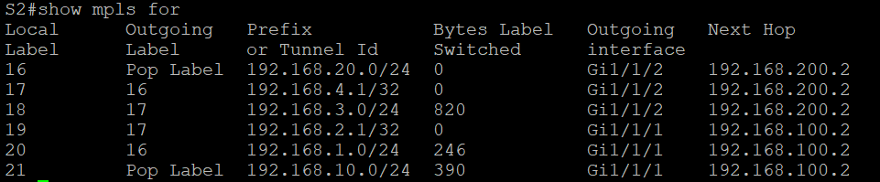

**Problems**

The only problem we had was a problem with an adapter from ethernet to the es port which stopped working so we had to just replace it.

**Conclusion**

Overall the MPLS implementation part was relatively simple as it only required 2 different commands, but even though the configuration was simple the way the protocol works is pretty complicated.